https://www.jdoodle.com/embed/v0/5NTj

Output
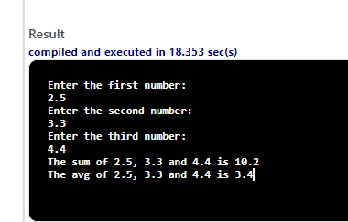

#include <iostream>

using namespace std;

int main ( )

{

//declare double variables for holding decimal values

double n1, n2, n3, sum, avg;

//Input numbers

cout << "Enter the first number:" << endl;

cin >> n1;

cout << "Enter the second number:" << endl;

cin >> n2;

cout << "Enter the third number:" << endl;

cin >> n3;

//compute the sum of the numbers and save it in the variable sum

sum=n1+n2+n3;

//compute the average and save it in the variable avg

avg=(n1+n2+n3) /3;

//display the first line of the output

cout << "The sum of " << n1 << ", " << n2 << " and " << n3 << " is " << sum << endl;

//display the second line of the output.

cout << "The avg of " << n1 << ", " << n2 << " and " << n3 << " is " << avg << endl;

return 0;

}

